Service Request Portal
Beginner's Guide
Raise, approve and track requests — step by step

Version | 1.1
Date | November 2026
Prepared by | IT Team
Who it is for | Every employee — requesters, approvers, Service Desk and engineers
Classification | Internal use only

Prepared by the Fareportal IT Team · For internal use only

1. Start here
The Service Request Portal is the one place to ask IT and the engineering teams for help — software, access, equipment and more. This guide shows you how, in a few simple steps.
Portal link: [ paste the portal URL here ]
Sign in with your company Microsoft account — the same one as Outlook. No extra password. It works on your phone too.

SCREENSHOT — Home page — what you see after signing in
Click here, then paste your screenshot (Insert → Pictures)

Your first request in 4 steps
1. Open the portal link above and sign in with your company account.
2. Pick a request type from the catalog on the Home page.
3. Fill in the short form, add files if they help, and select Submit.
4. Follow it in My Requests — you’ll get updates by email and in the portal.

Who does what
Requester | Approver | Engineer / Service Desk
Raises and tracks requests.  That’s every employee. | Approves or rejects requests  that need sign-off. | Does the work and keeps  the status up to date.

Most people are requesters. Some also approve or deliver work — if that’s you, read sections 5 and 6 as well.

2. How a request travels
Every request follows the same path. Here is the whole journey:
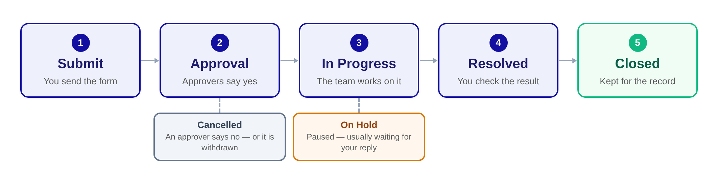

What each status means
Status | In plain words
Draft | Started, but not submitted yet.
Approval Pending | Waiting for the approvers to decide.
In Progress | The team is working on it.
On Hold | Paused — usually waiting for your reply.
Resolved | Work is done. Check it is what you need.
Closed | Confirmed and kept for the record.
Cancelled | Rejected or withdrawn. Raise a new one if you still need it.

You don’t need to remember any of this — the status always shows where the request is, and every step is saved in its history.

3. Raise a request

How to do it
1. On the Home page, pick the category that fits — or use New Request in the top bar.
2. Check your details at the top of the form.
3. Write a short, clear title, then describe what you need — and by when.
4. Answer the questions for that request type. For people fields, type a name and pick from the list.
5. Add attachments if they help (screenshots, files, approvals).
6. Select Submit at the bottom of the page.
SCREENSHOT — New request form
Click here, then paste your screenshot (Insert → Pictures)

What happens next
• You get a reference number — keep it for any questions.
• If approval is needed, the status shows Approval Pending. Otherwise it goes straight to In Progress.
• You are notified at every step.

Pick the right request type
Request type | Use it for
IT Enterprise | Software, access, mailboxes
HR Onboarding | Setting up a new joiner
HR Offboarding | Leaver access and equipment
InfoSec Exception | Security policy exceptions
System Engineering | Virtual machines, operating systems
DevOps | Pipelines and deployments
Cloud Engineering | Azure resources
Database | Databases and access
Voice Engineering | Phones and VoIP
Network | IPs, VLANs, connectivity

Not sure which one? Check the FAQ page, or ask the Service Desk.

4. Track it and talk

Track a request
1. Open My Requests to see all your requests and their status.
2. Select one to open it.
3. Check the status, the approvers, who it is assigned to, and the comments.
SCREENSHOT — A request page — status, comments and attachments
Click here, then paste your screenshot (Insert → Pictures)

Add a comment
1. Open the request and find the comment box.
2. Type your message. Type @ to bring a colleague in — pick them from the list.
3. Post it. They get notified straight away.

How you hear about updates
• In the portal: the bell in the top bar shows what’s new.
• By email: the same updates, with a link that opens the request.
You are told about approvals, status changes, comments and mentions — not about your own actions.

If something comes up
If this happens | Do this
Stuck at Approval Pending | Add a comment and @mention the approver. If they are away, ask the Service Desk to swap them.
The team asks you a question | Reply in a comment — the request may show On Hold until you do.
The status shows Resolved | Check the result, then confirm in a comment. If something is wrong, say what.
You no longer need it | Ask the Service Desk to cancel it in a comment.

5. Approve a request
You get an email and a notification when a request needs your decision.

How to decide
1. Open the request from the email link, or from Approvals in the top bar.
2. Read the details, the attachments and the comments.
3. Need more information? Add a comment and @mention the requester — it’s fine to wait.
4. Choose Approve or Reject.
5. Add a short comment to say why — always when you reject.

Sequential or parallel?
Some requests have one approver, some have several. The two ways it can work:
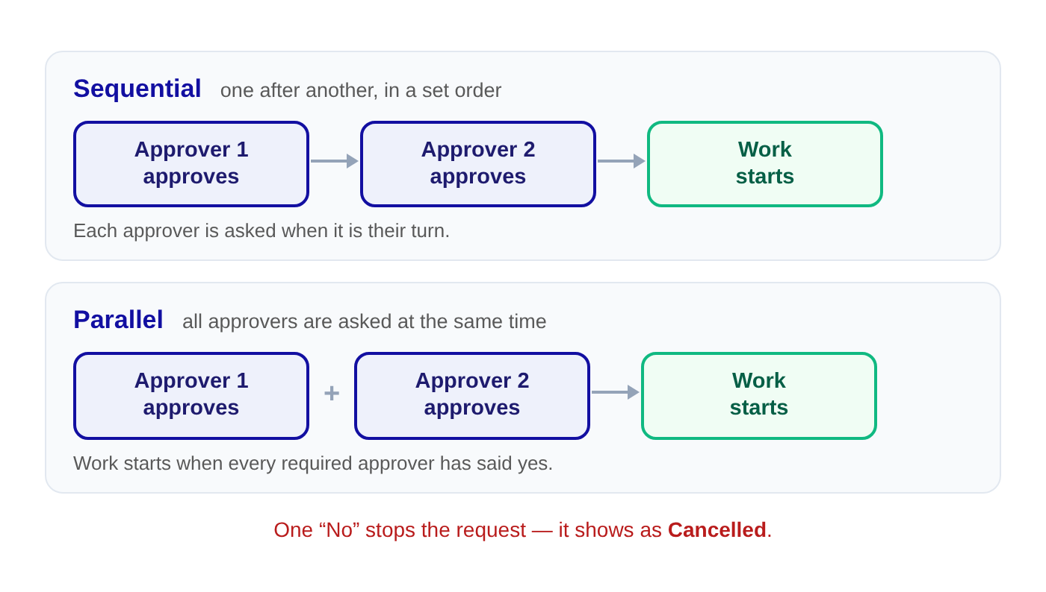
What happens next
• Approve: work starts once every required approver has approved.
• Reject: the request is cancelled, and the requester sees your reason.
• Your decision stays on the request as a record.

6. Work on a request
Requests reach you after approval — or straight away if none is needed.

Find it and assign it
1. Open Requests and filter the list — by your name, or “no assignee” for new work.
2. Read the details, the attachments and the approvals before you start.
3. In the request panel, pick the right assignee and save.
4. If they need context, @mention them in a comment.

Keep it moving
1. Update the status as work happens — In Progress, On Hold, Resolved.
2. Can’t continue? Comment what you need, @mention the requester, and set it to On Hold.
3. Got what you need? Set it back to In Progress.
4. Keep the conversation on the request — side chats and emails don’t reach its history.

Resolve it and close it
1. Done? Comment what you did, then set the status to Resolved.
2. Wait for the requester to confirm. If something isn’t right, set it back to In Progress and fix it.
3. Once confirmed, set it to Closed. The full history stays in the portal.
SCREENSHOT — Requests page — filters and your work list
Click here, then paste your screenshot (Insert → Pictures)

Status, priority and assignment are changed by the Service Desk team and admins. If you don’t see these options, ask them in a comment.

7. Good to know

Simple rules that make requests go faster
Do | Don’t
Give every request a clear title and enough detail. | Put passwords in a request, comment or attachment.
Keep all the talk on the request itself. | Raise the same request twice.
Reply quickly when someone asks you a question. | @mention people who aren’t involved.
Check your notifications now and then. | Leave a request waiting with no word.

Getting help
• Start with the FAQ page — your question may already be answered there.
• Contact the Service Desk with the reference number, what you were doing and what you saw on screen.
• Wrong name, department or manager on your profile? Those details come from the company directory — tell the Service Desk.
That’s it — you’re ready
Raise your first request, and come back to this guide any time.

